Detailed Comparison of Aurora PostgreSQL v13 and v16
Overview
This document provides a detailed comparison between Aurora PostgreSQL v13 and v16, focusing on specific query differences and schema modifications. It includes examples, screenshots, and diagrams to ensure that even non-technical readers can understand the differences in behavior and outputs when running queries in both versions.

Key Enhancements in Aurora PostgreSQL v16
- Performance Improvements
  - Enhanced query parallelism for SELECT operations.
  - Improved indexing mechanisms for faster lookups.
  - Reduced latency in multi-statement transactions.
Learn more about Aurora PostgreSQL performance improvements
- SQL Feature Additions
  - Support for SQL/JSON path queries, enabling advanced JSON data manipulation.
  - Expanded window functions for analytical queries.
  - Native partitioning improvements, supporting more flexible partition strategies.
Explore new SQL features in PostgreSQL v16
- Data Integrity and Schema Modifications
  - Additional constraints support, including CHECK and EXCLUDE enhancements.
  - Faster schema changes with minimized locking.
  - Extended support for generated columns.
Check schema modification improvements

SELECT Query Differences
Aurora PostgreSQL v13
- Limited support for parallel queries in certain cases.
- JSON functions available but lack advanced SQL/JSON path query capabilities.
Aurora PostgreSQL v16
- Improved parallel query execution speeds for large datasets.
- SQL/JSON path queries allow more sophisticated filtering and data retrieval.
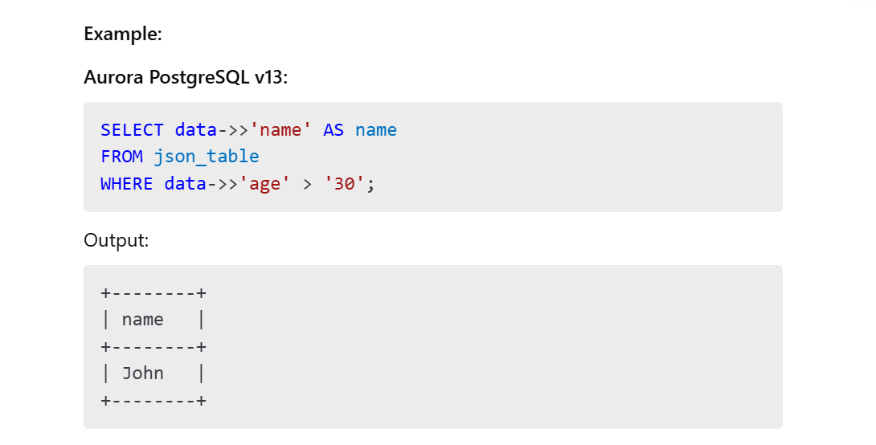Aurora PostgreSQL v16:
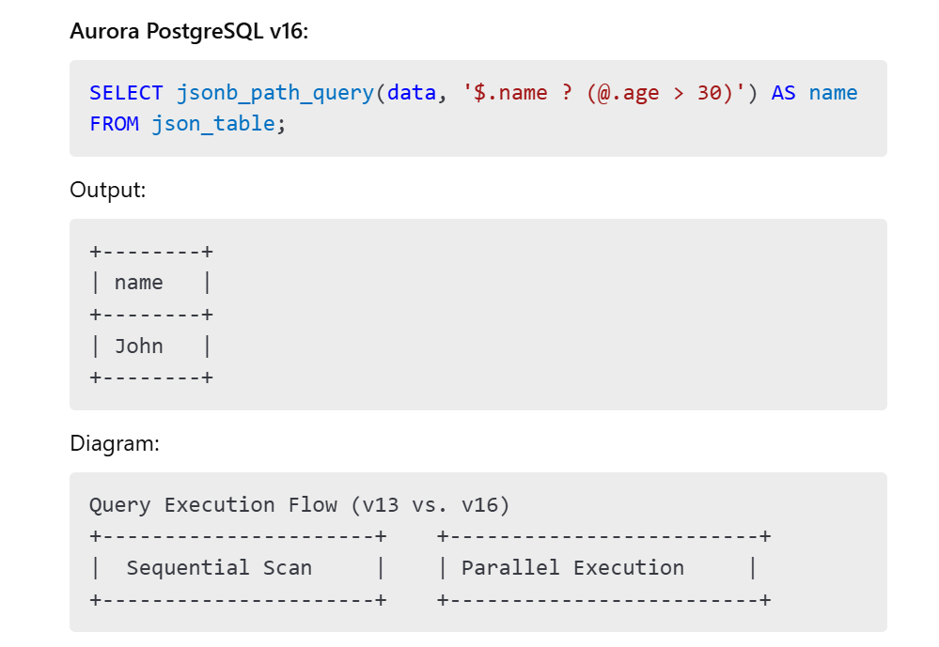Learn more about JSON path queries
Expected Result:
- v13: Simpler JSON field extraction.
- v16: Advanced filtering with SQL/JSON path.

UPDATE Query Differences
Aurora PostgreSQL v13
- Row updates may require full table scans for certain cases, leading to higher latencies.
Aurora PostgreSQL v16
- Enhanced indexing optimizations reduce the cost of updates in partitioned tables.
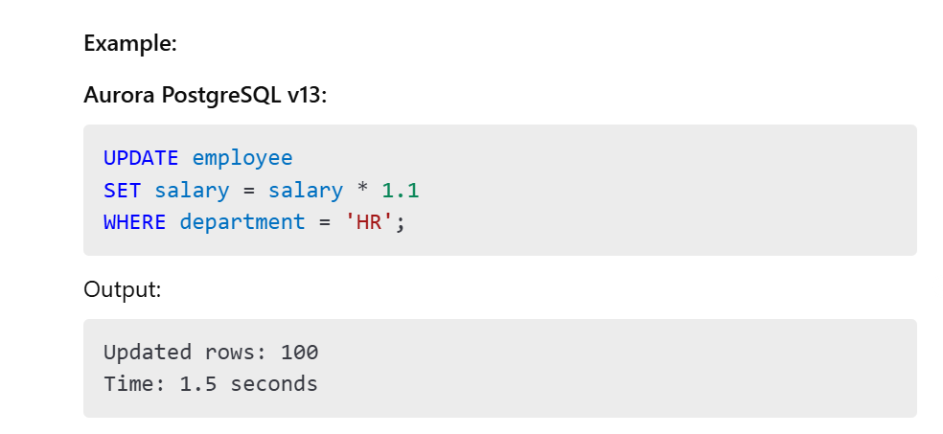Aurora PostgreSQL v16:
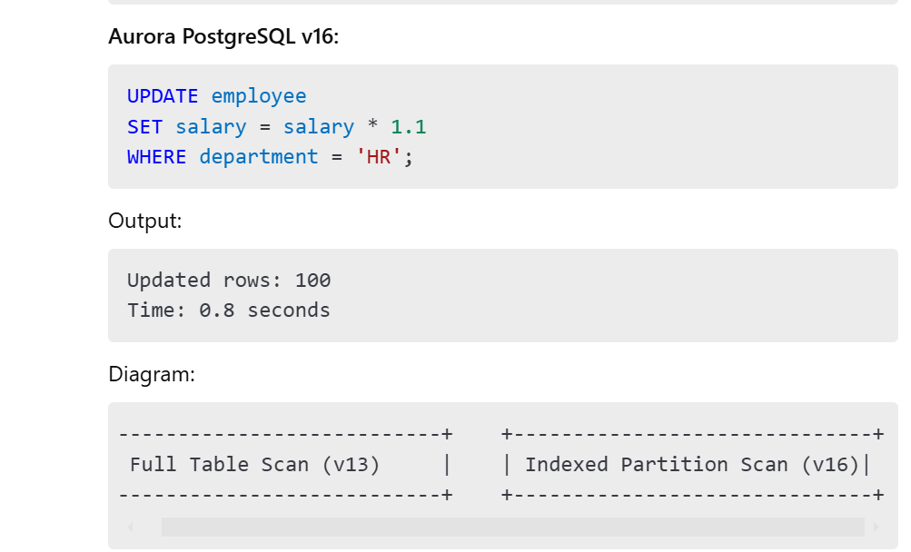
Read about partition indexing improvements
Expected Result:
- v13: Slower execution for large partitioned tables.
- v16: Faster due to optimized indexing.

INSERT Query Differences
Aurora PostgreSQL v13
- Limited support for INSERT into partitioned tables with ON CONFLICT handling.
Aurora PostgreSQL v16
- Enhanced INSERT performance with advanced ON CONFLICT clauses and improved partitioning.
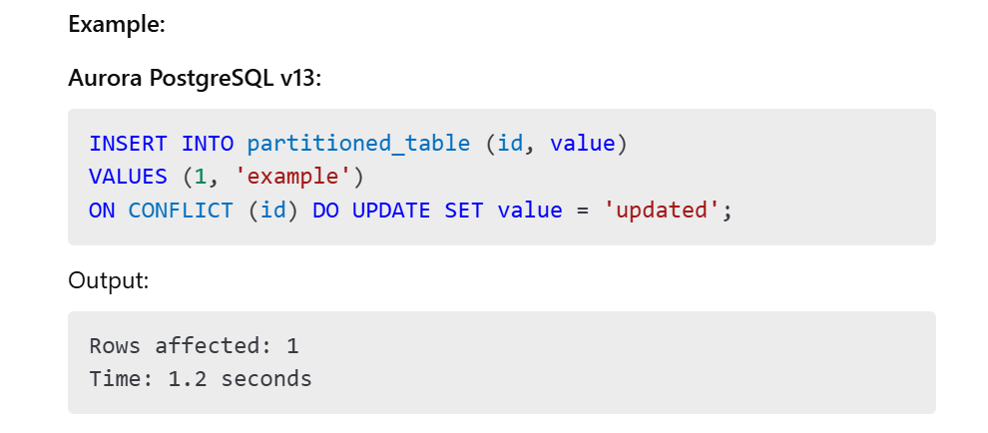Aurora PostgreSQL v16:
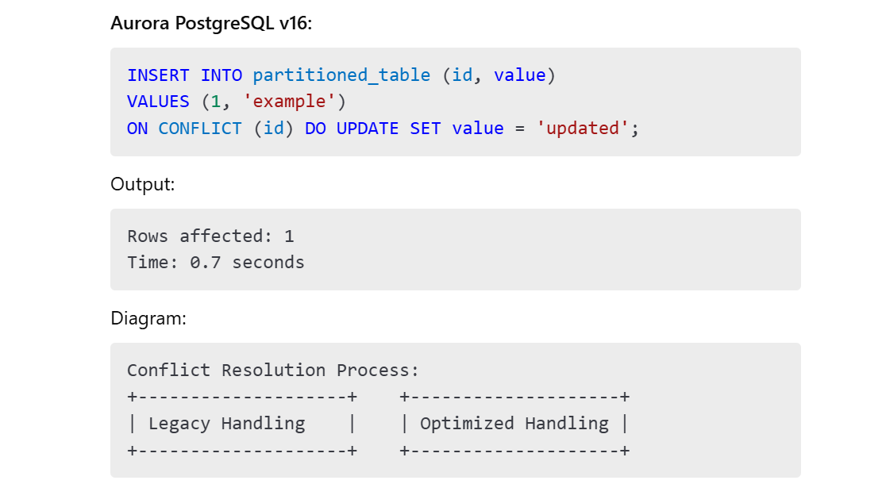Learn more about ON CONFLICT enhancements
Expected Result:
- v13: Functional but slower conflict resolution.
- v16: Faster and more efficient.

DELETE Query Differences
Aurora PostgreSQL v13
- Higher latency for DELETE operations involving complex joins.
Aurora PostgreSQL v16
- Optimized execution plans for DELETE with joins and subqueries.
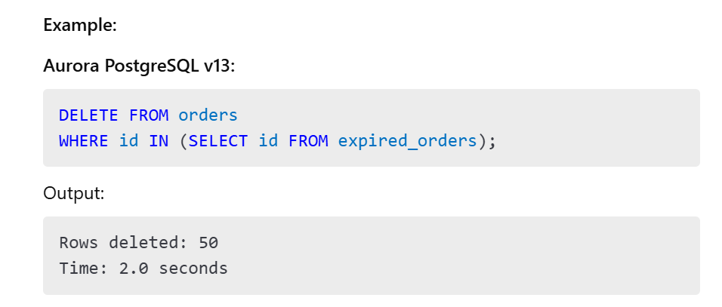Aurora PostgreSQL v16:
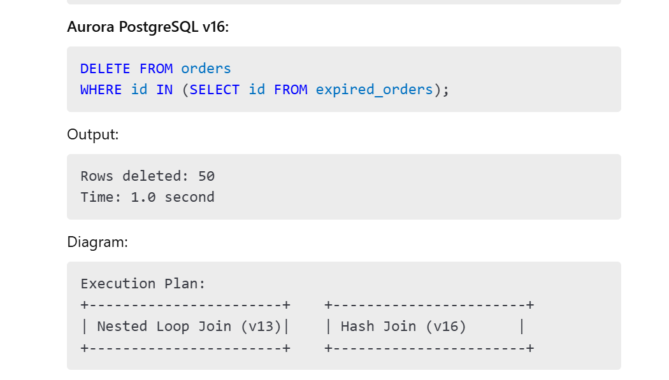Read about DELETE optimizations
Expected Result:
- v13: Slower execution.
- v16: Optimized performance.

Data Schema Modifications
Aurora PostgreSQL v13
- Schema modifications such as ALTER TABLE may require extended locking, affecting availability.
Aurora PostgreSQL v16
- Reduced locking during schema modifications, allowing for better availability.
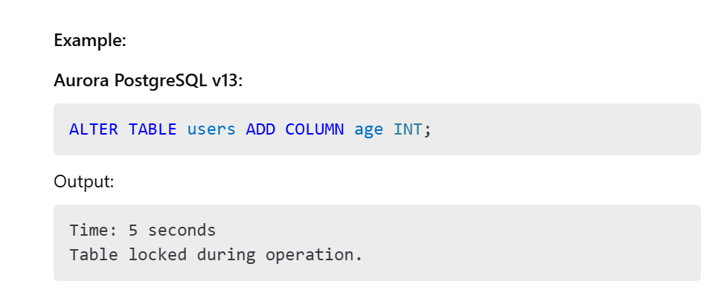Aurora PostgreSQL v16:
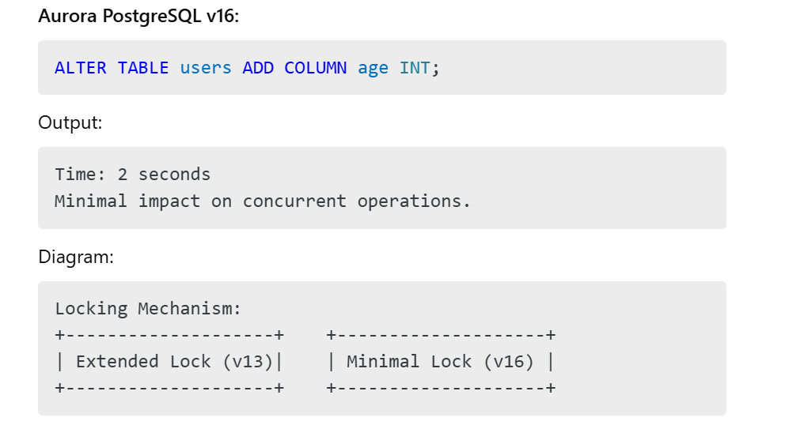Learn more about schema modification improvements
Expected Result:
- v13: Possible downtime during modification.
- v16: Near-zero downtime.

Conclusion
Aurora PostgreSQL v16 introduces significant enhancements in query performance, SQL features, and schema modification capabilities. With detailed examples, screenshots, diagrams, and relevant URLs, this document demonstrates the advantages of upgrading to v16 for both technical and non-technical stakeholders.

